Project Report

On

**Online Whiteboard**

**Submission Details:**

**Name:** Sonali Kumari

**Section:** CE-Core

**University Roll Number:** 2017381

**Guided By:** Sarishma Dangi

Semester : 04

**Department of Computer Science and Information Technology**

**Graphic Era Deemed to be University, Dehradun**

**Problem Statement:**

To create an online whiteboard that can be used to teach students/keep notes/paint (to some extends), etc.

#My Online Whiteboard!

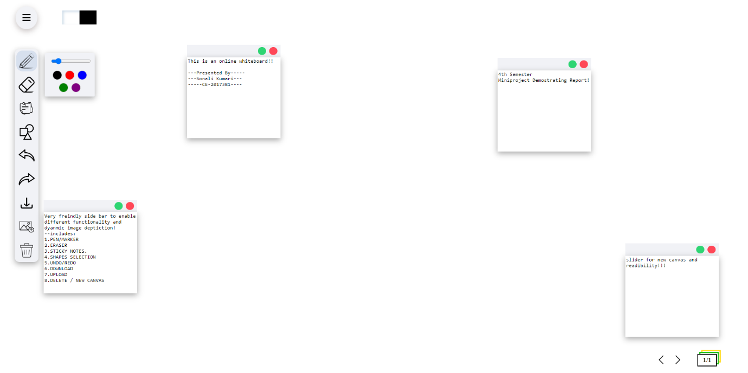

**Motivation:**

This project was one of the projects I always had in mind. It was so because this project was a perfect opportunity for me to test my skills in terms of Front-End web developer. So, I used this precious opportunity to test my skills and make an online whiteboard that can be implemented by working members of the society to either teach or keep notes. This whiteboard should be able to provide necessary tools required for making it user friendly and easy to apply. As you know that I am still a student trying to find my own ways around this field, this project is a work in progress project that will be getting updated as I keep on increasing my skills in this field of study.

**Languages Used:**

* HTML/HTML5
* CSS
* JavaScript

**Problem Analysis:**

We created a HTML file named *‘index’* in which all the whiteboard is situated. A CSS file named *‘style’* is also created in order to give the properties of the icons/logos we use for the tools that can be used in the whiteboard. There are also 2 JavaScript files present, namely *‘canvas’* and *‘tools’* that are being used for modifying as well as customising the features used in the canvas of the whiteboard and the tools in the whiteboard.

**Some Features of the Whiteboard:**

* **Pen tool** that helps in writing in the whiteboard.
* **Erase tool** that helps in erasing the writing that was written through the Pen tool.
* **Sticky Notes tool** used for keeping notes in a text manner rather than the usual pen tool drawing.
* **Shapes tool** for making different pre-built shapes in the whiteboard.
* **Undo tool** for Undoing recent moves/scribbles.
* **Redo tool** for Redoing the recent moves/scribbles that have been Undone.
* **Save and Download tool** for Downloading the current canvas for future use/reference.
* **Upload tool** for uploading a picture/image for getting reference from it by keeping it as Sticky Note.
* **Clear All tool** for clearing the canvas to its natural state.
* **Canvas Select tool** for usage of multiple Canvases during single session.
* **Presence of Blackboard** feature as well in the Canvas for people preferring Blackboard rather than Whiteboard for keeping notes or for teaching.
* **Hide List tool/icon** for hiding the list of tools when not required by the user for better Whiteboard experience.
* **Colour contrast in Whiteboard and Blackboard** for better user experience.

**Methodology:**

Since it had to be an online whiteboard, we first created a html file named ‘index’ that contained all the necessary for making the canvas that can be later modified or utilized by the CSS and JavaScript files for making the board interactive. The html file has the basic elements required for the whiteboard. Now, using the CSS language, we created a file containing all the necessary objects and classes required for the logos and icons to be used for the tools in the whiteboard and the colour palette required for the lines and markings of the drawing tools in the Whiteboard. CSS also has the attributes necessary for the change of Whiteboard to Blackboard. The JavaScript files are used for implementing a script required for the utilisation and Actions of the mouse to draw/erase in the Whiteboard. Two different JavaScript Files were created for better control of the code. Tools JavaScript file is used to script the utilisation/functioning of the tools in the Whiteboard. The Canvas JavaScript file is used to improve the Actions/Events of the Canvas of the Whiteboard. This file also has the attributes required for the change of colour scheme/palette as per the White/Black or Light/Dark mode of the Whiteboard that I have created.

Using these files, we can successfully run the Whiteboard. There is also a presence of Icons folder used for the icons used in the Whiteboard platform. This Whiteboard, although stable, is a Work In Progress that will be updated in the future with the increase in my skill in the languages and usage of the languages of CSS, JavaScript and HTML/HTML5, etc.

**Some Screenshots of the usage of the Whiteboard and Blackboard/Whiteboard (Light And Dark mode):**

1. Shapes in Whiteboard (Light Mode)

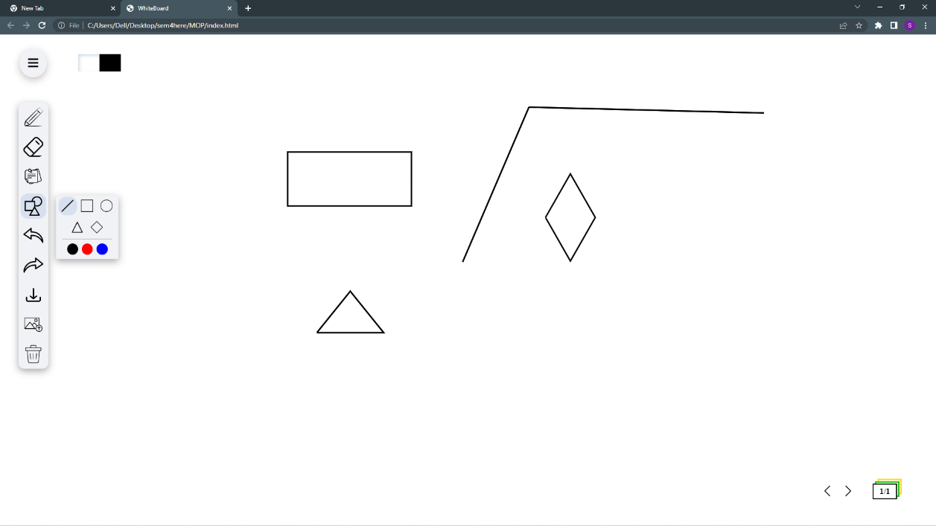

1. Usage of Sticky Notes and writing pen.(Dark Mode)

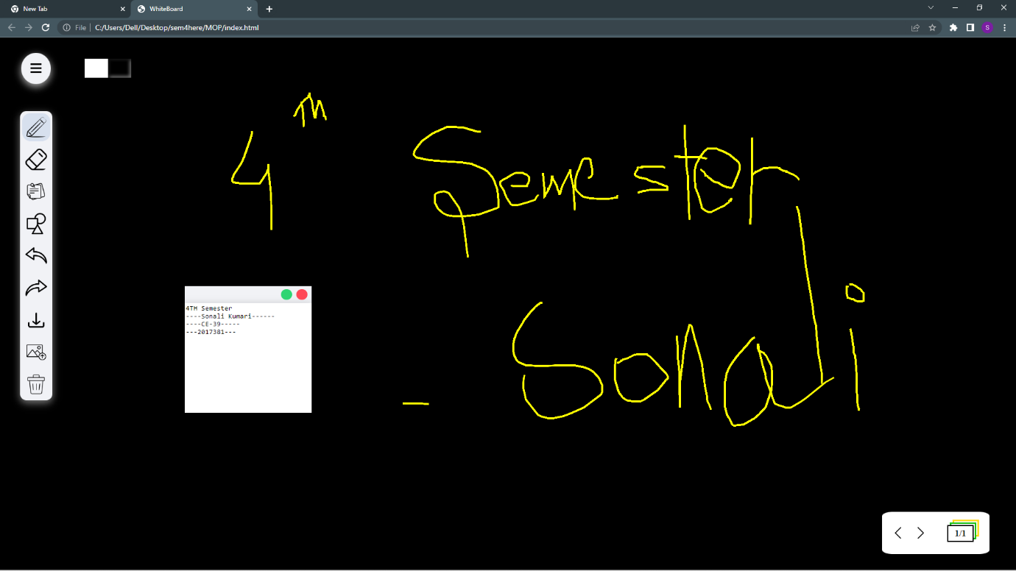

3.Writing is easy and new canvas Slide/Layer in the same section.

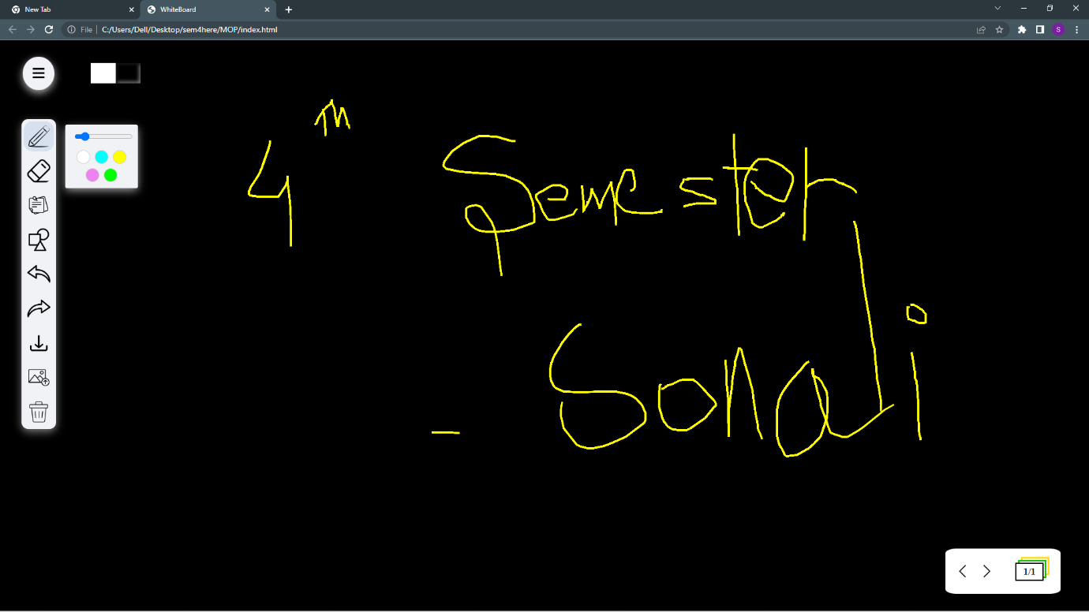

4.Usage of Upload tool.

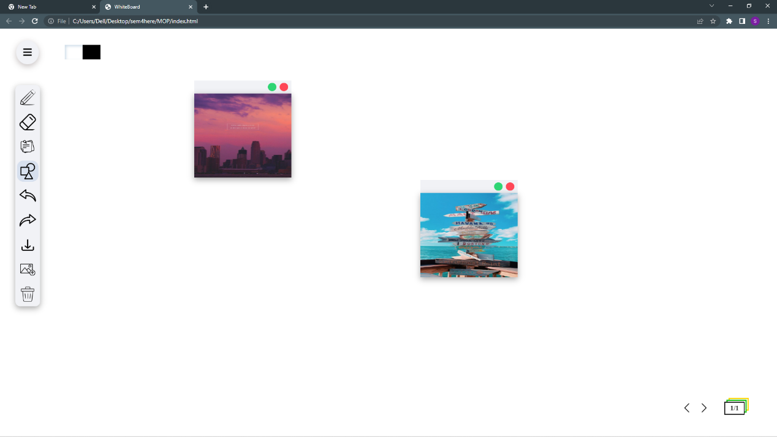

**Conclusion:**

This was a relatively twisting and hard-implementation project that really tested my bounds in the field of Front-End Web Development. This also was a really interesting and fun project to do as I got to learn many things in the CSS, JavaScript and HTML5 language while doing it. I learnt how to use functions that let us do event and action handling as well as implement them in such a manner that we can use it to draw/erase in the Whiteboard. As I have mentioned before, this project is still a Work in progress as I have many ideas of implementing cursor change on selection of tool and RGB wheel for selecting colour and many other features that can be used for making the Whiteboard user-friendly. It has also pushed me to learn many new concepts.

**Bibliography:**

* <https://youtu.be/Lj9QZOPPy3I>
* <https://iconmonstr.com/>